**Ideation Phase**

**Define the Problem Statements**

|  |  |
| --- | --- |
| Date | 31 January 2026 |
| Team ID | LTVIP2026TMIDS88360 |
| Project Name | Civil Engineering Insight Studio |
| Maximum Marks | 2 Marks |

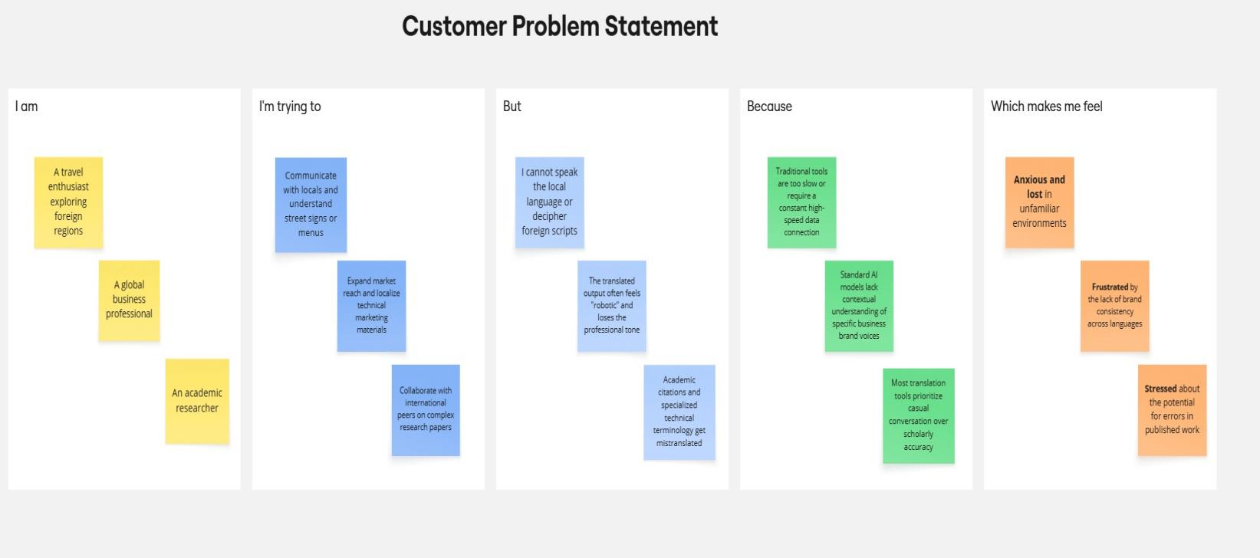**Customer Problem Statement**

|  |  |  |  |  |  |
| --- | --- | --- | --- | --- | --- |
| **Problem**  **Statement (PS)** | **I am**  **(Customer)** | **I’m trying to** | **But** | **Because** | **Which makes me feel** |
| PS-1 | A travel enthusiast exploring foreign regions | Communicate with locals and understand street signs or menus | I cannot speak the local language or decipher foreign scripts | Traditional tools are too slow or require a constant high-speed data connection | Anxious and lost in unfamiliar environments |
| PS-2 | A global business professional | Expand market reach and localize technical marketing materials | The translated output often feels "robotic" and loses the professional tone | Standard AI models lack contextual understanding of specific business brand voices | Frustrated by the lack of brand consistency across languages |
| PS-3 | An academic researcher | Collaborate with international peers on complex research papers | Academic citations and specialized technical terminology get mistranslated | Most translation tools prioritize casual conversation over scholarly accuracy | Stressed about the potential for errors in published work |